Announcements  Welcome back to Zion!  As a reminder, you must register for our Sunday services using Eventbrite (found on our website - zionsaskatoon.com) or by calling Kaylyn at the office (306-653-2442). You must register by noon the Friday before the service.  You can also watch the service on our YouTube channel (search  “Zion Lutheran Church Saskatoon” on YouTube)  Please note – if you, or someone in your family, is not feeling well, we ask that you reconsider attending in person.  Masks will be mandatory and disposable masks will be available at the church for those who do not have one. There will be directional arrows on the floor indicating entrances and exits. Please enter the church through the south door and exit via the parking lot door (except those with need of the lift).  We will not be serving communion today. We plan to serve communion in person again on Thanksgiving Sunday.  All of the brochures, pamphlets, etc. have been removed from the Narthex. They are available in the main office. Please contact  Kaylyn if you are interested in viewing anything (Canada Lutheran, Prayer Points, Gifts from the Heart Catalogue, Eternity for Today, etc).  Join Pastor Ron for prayer 10:00 Wednesday morning by Zoom or  in person (in the Chapel). Call or email the church office if you’d like  to participate.  We are in need of more volunteers to help with our Sunday Service recording and live streaming. If you can help, contact the office. | Announcements  OFFICE HOURS: Mon – Fri 9:00 am – 4:00 pm  Zion Contact Information  323 4th Ave Saskatoon, SK S7K 1N3  P: 306-653-2442  E: zion.office@sasktel.net  W: zionsaskatoon.com  Worship Assistants:  Musician: Diane Bestvater  Reader: Cami Cameron  Announcing…The Bible “Book of the Month” Club!!  Our Evangelical Lutheran Church in Canada Bishop Susan Johnson is challenging all 200,000 of her flock to read a book of the Bible every month for the next twelve months… at least!  Let’s start with an easy one, a big one, a long one: the first book of the Bible, Genesis! If we commit to reading two chapters on every reading day (counting the Saturdays but not the Sundays), we will read the whole of Genesis in October!  And bring your Bible reading, prayers, questions, and insights, to the Bible Study group meeting on Tuesdays from 12:30-2:00 in the Chapel, either in person or by Zoom. Please pre-register so we can physically distance or look for you on-line. Our first fall Bible Study Group meeting is planned for Tuesday, October 6 starting at 12:30.  Don’t procrastinate… start reading today!  In Our Prayers: Derwin Hall, Andrea Nostbakken, Nandari Swamy, Martin, Weldeyesus family, Mallory Jess, Ken Finnestad, Wally Cubbon, Cecelia Jurgens, Vibs Paulsen, Neil Taylor, Vi Stalwick, Elaine Lindgren family, Robert Lamon, Dale Stalwick, Gloria Hamp, Shirley & her sister Lena & their family, Adam, Betty McManus, Aaron Froese, family of Gene Grant | Welcome  Confession and Absolution  Gathering Songs: All Things Bright and  Beautiful (vs. 1 & 3)  Kyrie – pg. 157  Prayer of the Day:  Beloved God, from you come all things  that are good. Lead us by the inspiration of your Spirit to know those things that are  right, and by your merciful guidance, help  us to do them, through Jesus Christ, our  Savior and Lord. Amen.  First Lesson: Isaiah 5:1-7  Psalm 80:7-15  Second Lesson: Philippians 3:4b-14  Gospel: Matthew 21:33-46  Sermon  Apostles’ Creed  Prayers of Intercession  Offering: Accept, O Lord, the Gifts we Bring –  ELW #691  Lord’s Prayer – Our Father in heaven… (choir)  Benediction  Sending Song: Christ, Whose Glory Fills the  Skies – ELW #553
Scripture Lessons:  Isaiah 5:1-7  Let me sing for my beloved my love-song concerning his vineyard:  My beloved had a vineyard on a very fertile hill.  He dug it and cleared it of stones, and planted it with choice vines;  he built a watch-tower in the midst of it, and hewed out a wine vat in it;  he expected it to yield grapes, but it yielded wild grapes.  And now, inhabitants of Jerusalem and people of Judah, judge between me and my vineyard.  What more was there to do for my vineyard that I have not done in it?  When I expected it to yield grapes, why did it yield wild grapes?  And now I will tell you what I will do to my vineyard.  I will remove its hedge, and it shall be devoured;  I will break down its wall, and it shall be trampled down.  I will make it a waste; it shall not be pruned or hoed, and it shall be overgrown with briers and thorns;  I will also command the clouds that they rain no rain upon it.  For the vineyard of the Lord of hosts is the house of Israel, and the people of Judah are his pleasant planting;  he expected justice, but saw bloodshed;  righteousness, but heard a cry!  Philippians 3:4b-14  even though I, too, have reason for confidence in the flesh.  If anyone else has reason to be confident in the flesh, I have more: circumcised on the |  | eighth day, a member of the people of Israel, of the tribe of Benjamin, a Hebrew born of Hebrews; as to the law, a Pharisee; as to zeal, a persecutor of the church; as to righteousness under the law, blameless.  Yet whatever gains I had, these I have come to regard as loss because of Christ. More than that, I regard everything as loss because of the surpassing value of knowing Christ Jesus my Lord. For his sake I have suffered the loss of all things, and I regard them as rubbish, in order that I may gain Christ and be found in him, not having a righteousness of my own that comes from the law, but one that comes through faith in Christ, the righteousness from God based on faith. I want to know Christ and the power of his resurrection and the sharing of his sufferings by becoming like him in his death, if somehow I may attain the resurrection from the dead. Not that I have already obtained this or have already reached the goal; but I press on to make it my own, because Christ Jesus has made me his own. Beloved, I do not consider that I have made it my own; but this one thing I do: forgetting what lies behind and straining forward to what lies ahead, I press on towards the goal for the prize of the heavenly call of God in Christ Jesus.  Matthew 21:33-46  ‘Listen to another parable. There was a landowner who planted a vineyard, put a fence around it, dug a wine press in it, and built a watch-tower. Then he leased it to tenants and went to another country. When the harvest time had come, he sent his slaves to the tenants to collect his produce. But the tenants seized his slaves and beat one, killed another, and stoned another. Again he sent other slaves, more than the first; and they treated them in the same way. Finally he sent his son to them, saying, “They will respect my son.” But when the tenants saw the son, they said to themselves, “This is the heir; come, let us kill him and get his inheritance.” So they seized him, threw him out of the vineyard, and killed him. Now when the owner of the vineyard comes, what will he do to those tenants?’ They said to him, ‘He will put those wretches to a miserable death, and lease the vineyard to other tenants who will give him the produce at the harvest time.’  Jesus said to them, ‘Have you never read in the scriptures:  “The stone that the builders rejected has become the cornerstone;  this was the Lord’s doing, and it is amazing in our eyes”?  Therefore I tell you, the kingdom of God will be taken away from you and given to a people that produces the fruits of the kingdom. The one who falls on this stone will be broken to pieces; and it will crush anyone on whom it falls.’  When the chief priests and the Pharisees heard his parables, they realized that he was speaking about them. They wanted to arrest him, but they feared the crowds, because they regarded him as a prophet. |  | 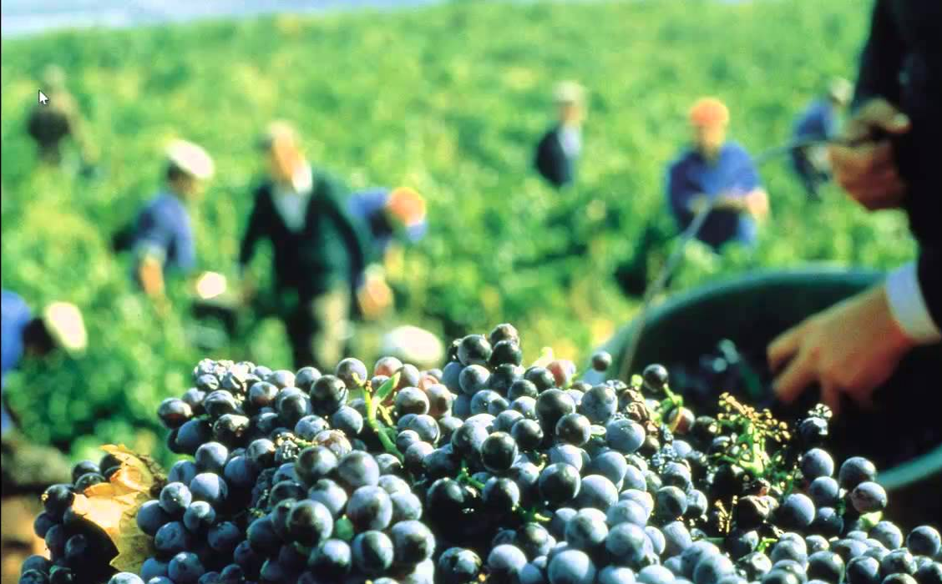  18th Sunday After Pentecost  October 4, 2020  10:30 am Worship Service

